A000-Asia-China-Shang-Alligator with Muntjak Deer Horns-Bronze-1200 BCE

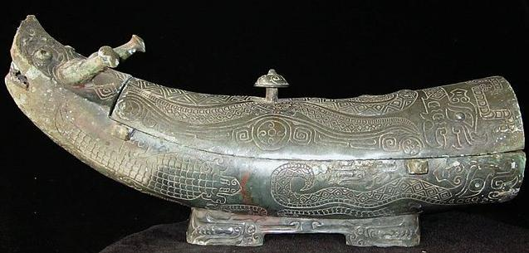

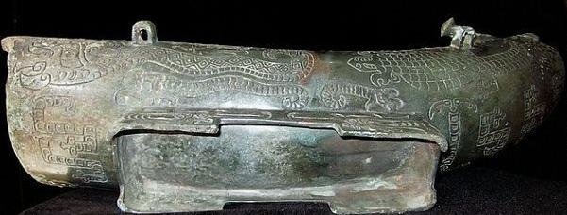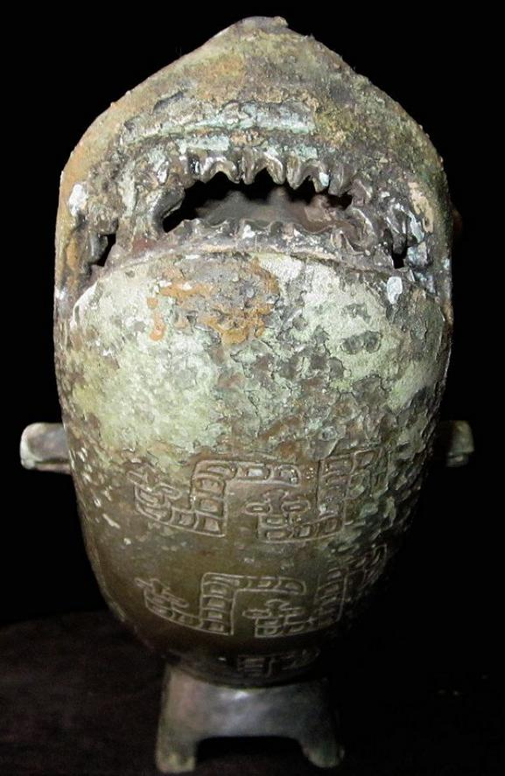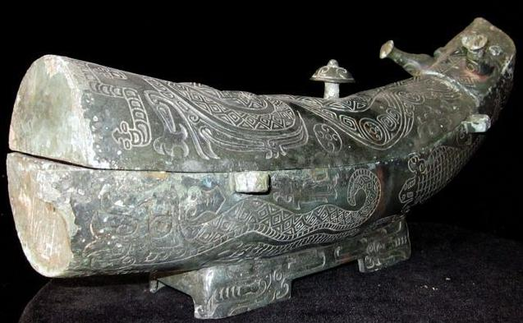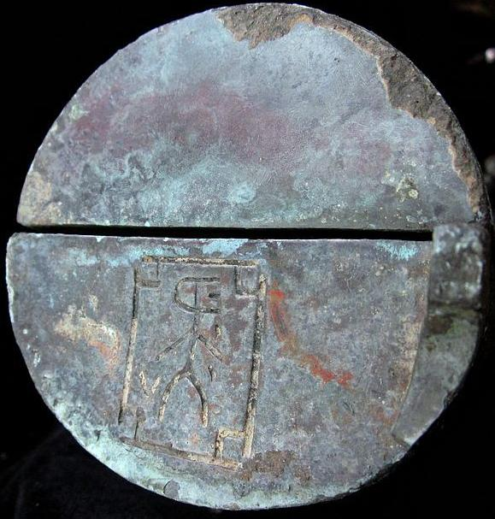

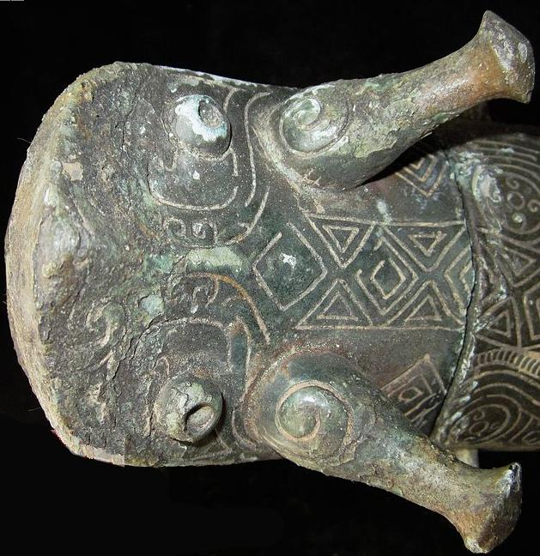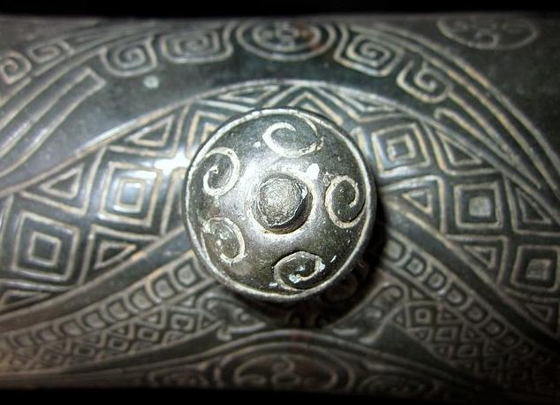

Water wave carvings on knob with diamond reptilian skin pattern of snakes on lid.

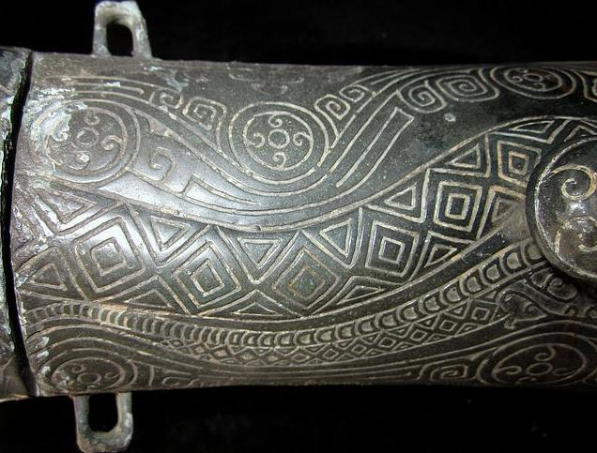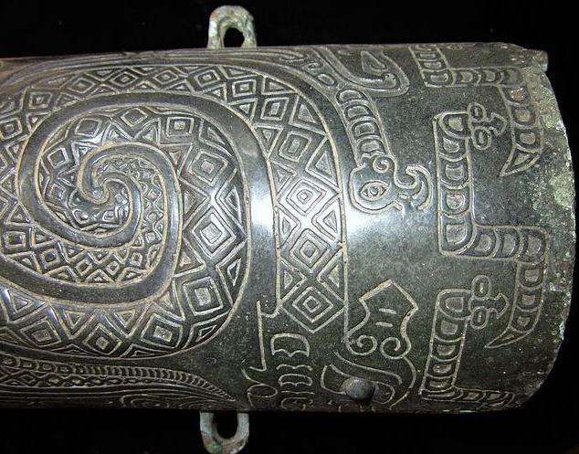

4Rings on the body, which was used for connecting the rope and body..

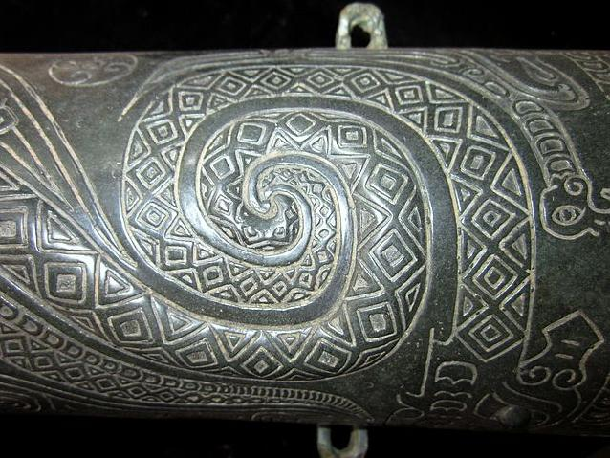

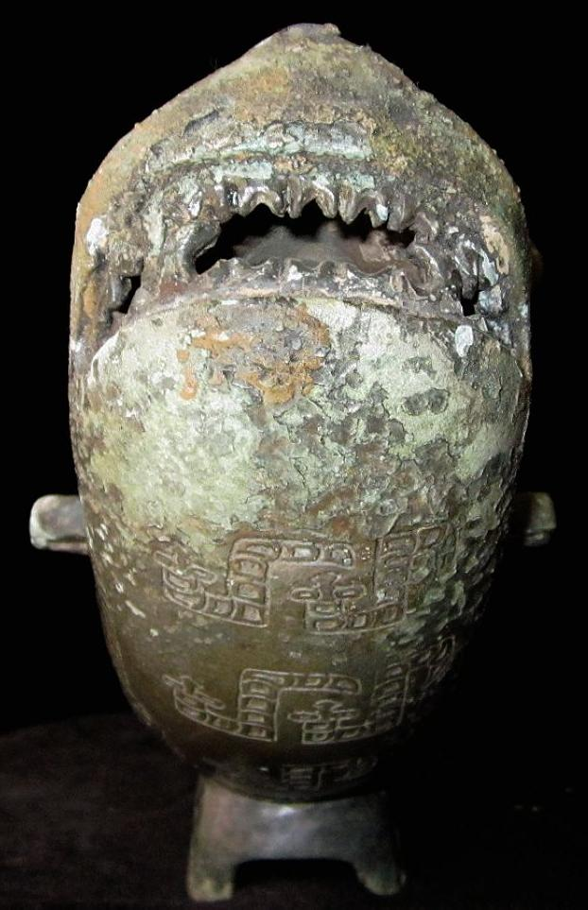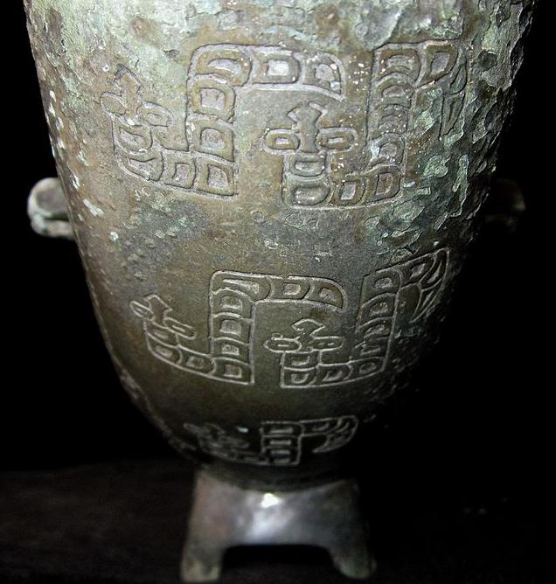 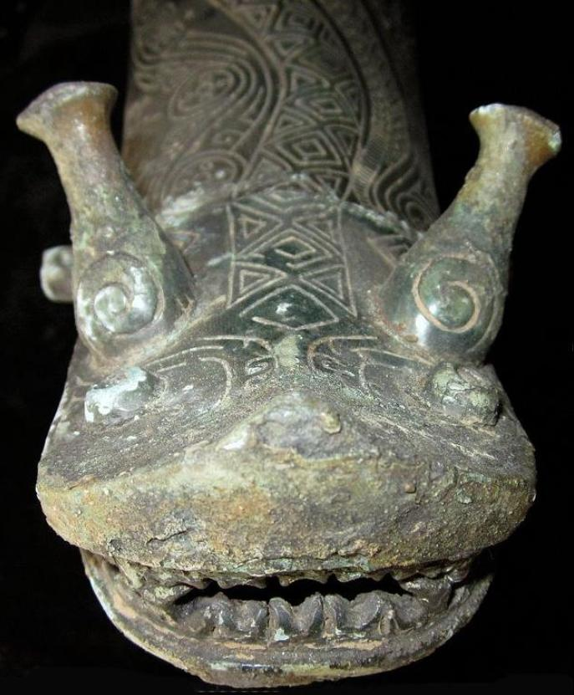

View of snout and composite antler-horns: bottle-shaped muntjak deer antlers with curved argali horns carved on them.

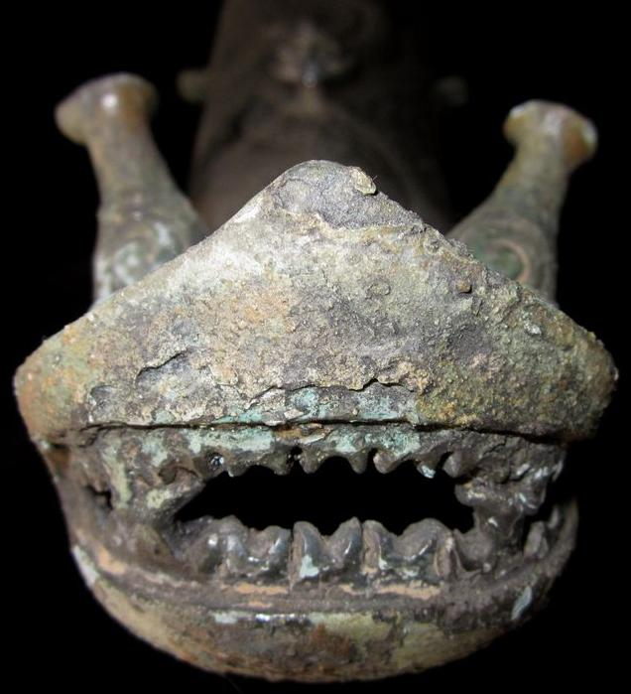

Shark-like snout with shark-like teeth.

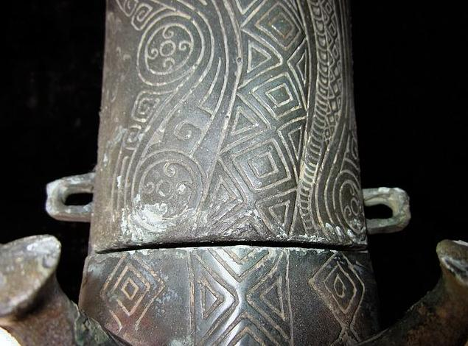

Composite curvilinear water motifs within circles and diamond patterned snake skin on dorsal ridge.

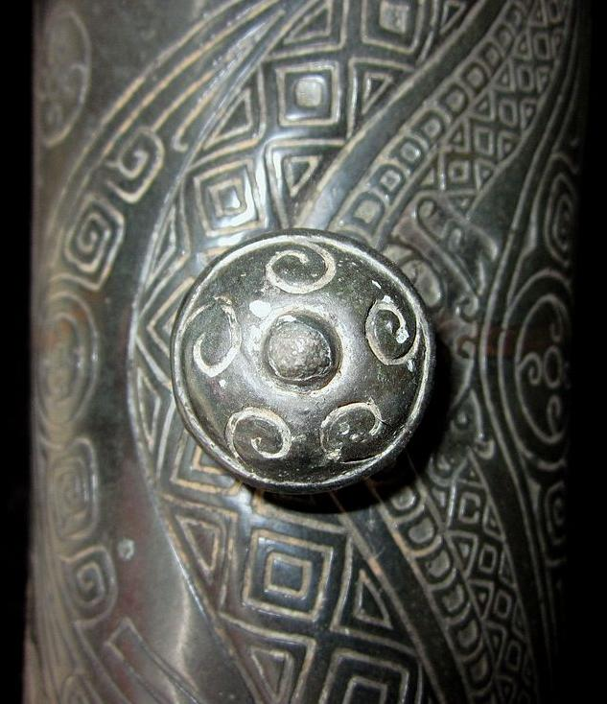

Water wave carvings on knob with diamond snake-skin pattern on lid.

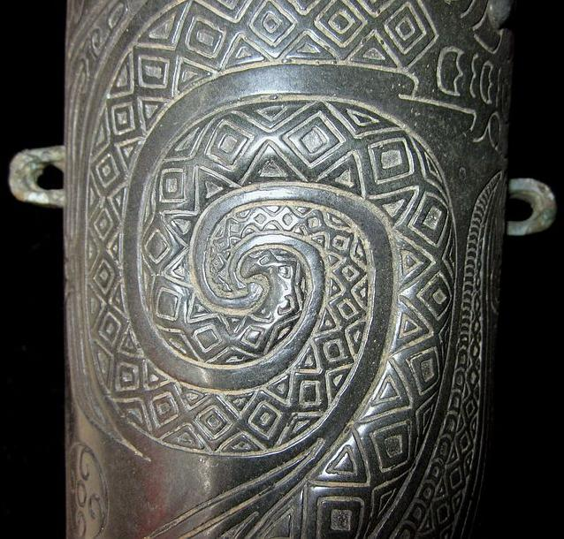 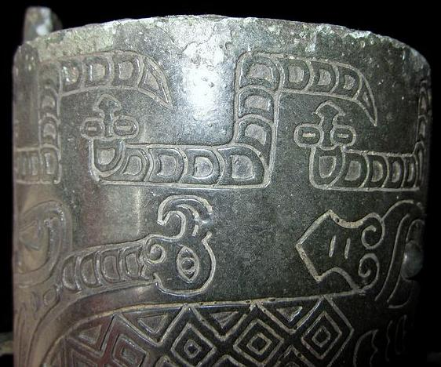 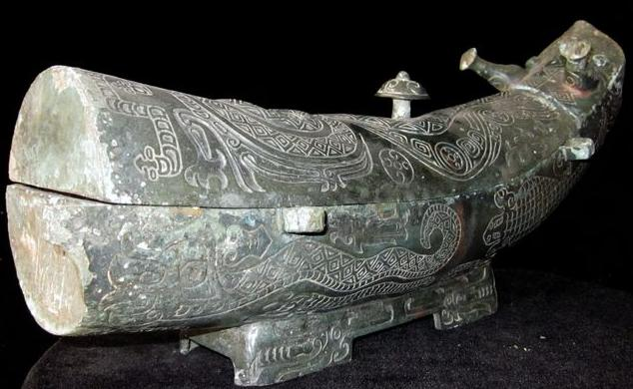 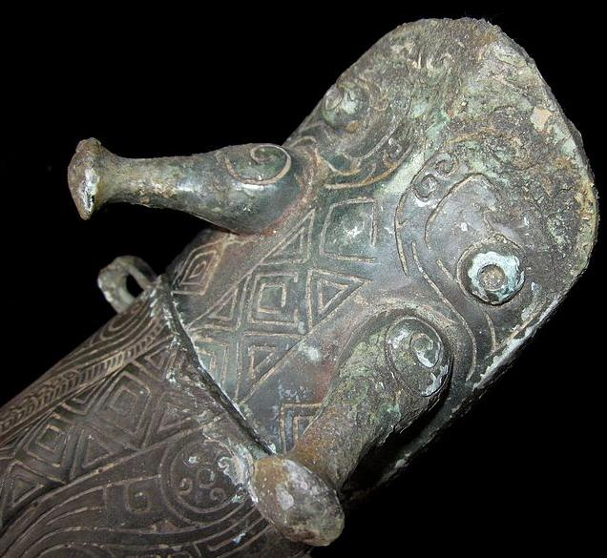 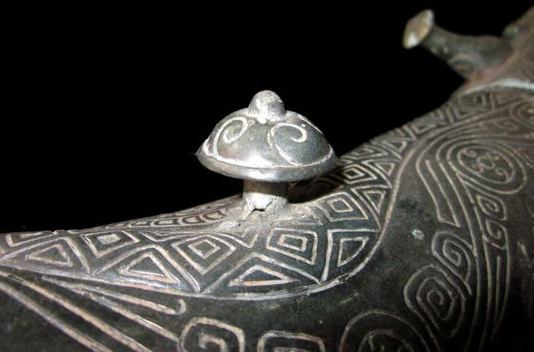 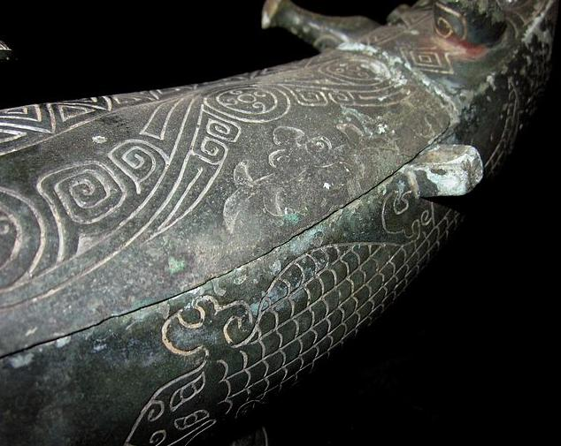 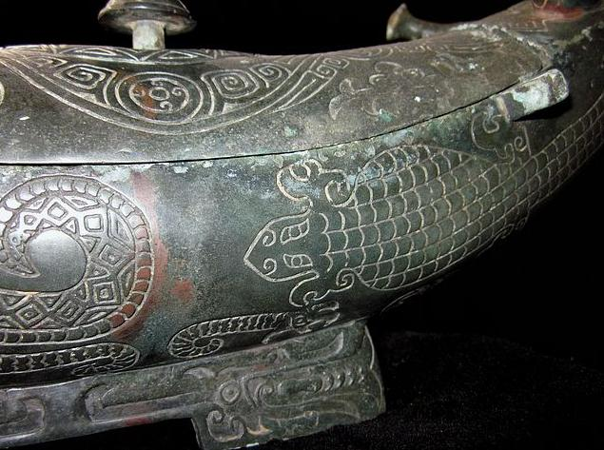 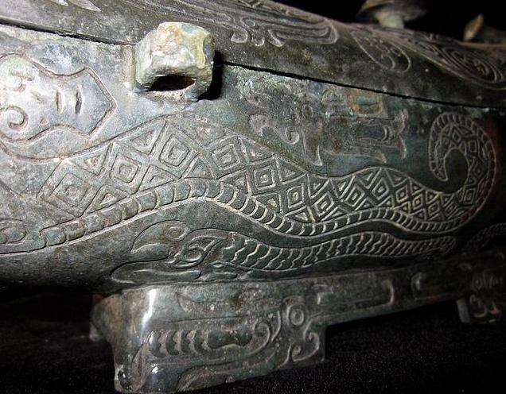 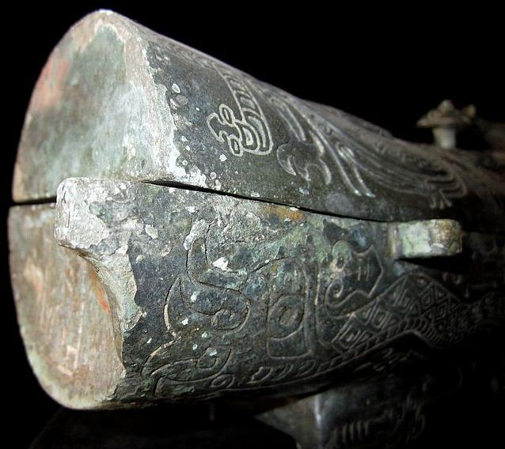 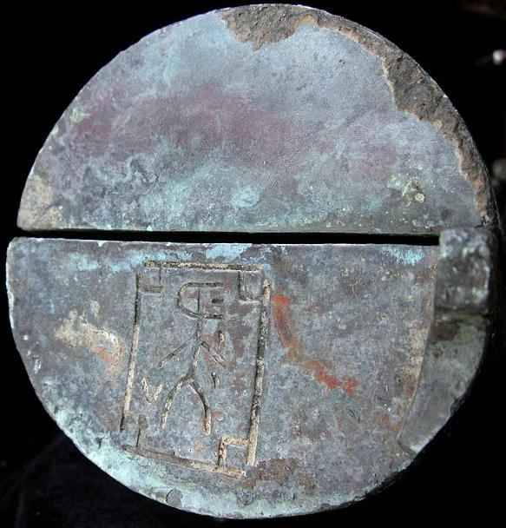

Sealing words on the body.

Case No.: 5

**Accession No.**

**Formal Label:**

**Display Description:**

**LC Classification:**

**Date or Time Horizon:**

**Geographical Area:**

**Map:**

**GPS coordinates:**

**Cultural Affiliation:**

**Media:**

**Dimensions:**

**Weight:**

**Condition:**

**Provenance:**

**Discussion:**

**References:**

NK5750

LENGTH:38CM/14.96Inches

HEIGHT:17CM/6.69Inches

Credible Antique,very rare. Bronze Wine Ware Pot GONG.Dragon Statues on the body.Beautiful color with proper size. CONDITION:Rust on the body, museum quality